#### 

# **PROJECT REPORT**

#### 

#### 

#### **MINDSTONE-D**

#### 

#### 

#### 

#### 

#### **MEMBERS**

Vidisha Wagle - 17070122075

Urvi Rawat -17070122070

Gaurav Joshi -17070122021

Mark Angelo -17070122041

Harika Challa - 17070122017

**DECLARATION**

We hereby declare that the project work entitled ― MindStone-D is an authentic record of our own work carried out at as requirements of a six months service learning project for Symbiosis Institute of Technology Pune, affiliated to Symbiosis International (Deemed University).

**TABLE OF CONTENTS**

|  |  |
| --- | --- |
| **INDEX** | **PAGE NUMBER** |
| 1. **Acknowledgement** | 5 |
| **2.**  **Introduction** | 6 |
| **3. Market Research** | 6-7 |
| **4. Literature Review** | 8 |
| **5. Problem Statement** | 8-9 |
| 5.1 Background | 8 |
| 5.2 Need For Doing This Project | 8 |
| 5.3 Benefits | 9 |
| 5.4 Limitations | 9 |
| **6. Requirements** | 9-10 |
| 6.1 Platform/Technology | 10 |
| **7. Project Planning** | 10-12 |
| 7.1 Work Distribution | 10 |
| 7.2 Time Logs | 11 |
| 7.3 Data Collection | 11-12 |
| **8. Project Design** | 12-16 |
| 8.1 Code Snippets | 12-13 |
| 8.2 Layouts | 13-16 |
| **9. Implementation** | 16-18 |
| 9.1 Modules | 16-17 |
| 9.2 System Model | 18 |
| **10. Testing** | 18-21 |
| 10.1 Debugging | 18-19 |
| 10.2 User feedback and analysis | 19-21 |
| **11. Conclusion and Future Enhancements** | 21-22 |

**1. ACKNOWLEDGEMENT**

The success and final outcome of this project required a lot of guidance and assistance from many people and we are extremely fortunate to have received this all along the completion of our project work. Whatever we have done is only due to such guidance and assistance and we shall not forget to thank them.

First and foremost, we would like to express our gratitude and praise to Symbiosis Institute of Technology, Pune and Department of Computer Science and Information Technology for giving us this wonderful opportunity to undergo the Service Learning Project Work, helping us to learn and get a great experience.

We heartily thank our project guide, Ms. Pooja Bagane for cooperating with us and giving us her valuable time and information.

We owe our profound gratitude and special thanks to Prof. Ismail Akbani who in spite of being extraordinarily busy with his duties, took time out to hear, guide and keep us on the correct path by his untiring feedback and suggestions and also agreed to collaborate with us for social entrepreneurship camps that are to be organized by EPIC.

At last we are grateful to our respected teachers Department of Computer Science and Information Technology SIT, Pune, family and friends for their help, encouragement and co- operation during the project work.

**2. INTRODUCTION**

In this project, making using of a series of questions, we aim to predict early signs of various disorders in our users. Along with this we provide information from treatment to symptoms to our user and also attempt to lighten up their mood, with our mood lifter section. Our personality test and contact for help section makes our app more intimate. The objective of our project is to provide a platform for our uses to detect early signs and know more about their disorder and thus reach a better conclusion.

**3. MARKET RESEARCH**

We researched and gathered data from online sources and conducted surveys regarding the topic. This helped us to understand their perspectives as to get an idea on how to proceed with it and can help the society. The following survey illustrated that the need for an fair amount of help to the user while coming up with a holistic diagnosis of the user.

1. Most people try and mask their emotions and symptoms related to mental disorders.

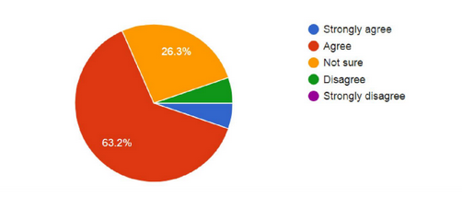

**2)** Would you like to use an app that might aid in this field?

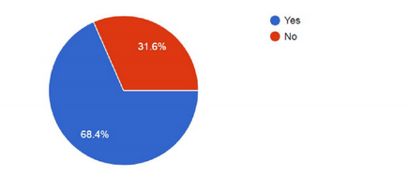

**3)** How difficult is it to elicit/interpret symptoms of the mind (your emotional state) ?

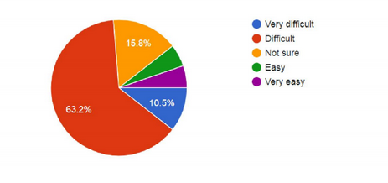

**4. Literature Review**

A mental disorder, also called a mental illness or psychiatric disorder, is a behavioral or mental pattern that causes significant distress or impairment of personal functioning. Such features may be persistent, relapsing and remitting, or occur as a single episode. Many disorders have been described, with signs and symptoms that vary widely between specific disorders. Such disorders may be diagnosed by a mental health professional.

After some research we realised that the following were the most common types of disorders-

* Clinical depression
* Anxiety disorder
* Borderline personality disorder
* Post Traumatic Stress Disorder
* ADHD

On research we came across various apps like Youper, Moodpath, OCD. Picking out the features we liked, and improving on some existing features, and some new additions of our own, MindStone-D was born.

**5.Problem Statement**

**5.1 Background**

This app mainly focuses on the state on the human mind.It’s been divided into categories as per the need of people on a more common basis so as to diversify what we have to offer, to the user as well as bring what’s majorly required for them on one particular platform. It mainly targets users between the age 15-35. It would be useful for people who are upset and sad over something trivial basically, can get over it in a short period of time or for someone who is at the beginning stages of some serious illness in the head. This app would be easy accessible and user-friendly.

**5.2 Need for doing the project**

Mental health includes our emotional, psychological, and social well-being. It affects how we think, feel, and act. It also helps determine how we handle stress, relate to others, and make choices. Which is why it is important at every stage of life, from childhood and adolescence through adulthood.

Unlike popular belief, mental health issues are in fact pretty common -

In 2014, about:

* One in five adults experienced a mental health issue
* One in 10 young people experienced a period of major depression
* One in 25 adults lived with a serious mental illness, such as schizophrenia, bipolar disorder, or major depression

Suicide is the 10th leading cause of death in the world . It accounts for the loss of more than 41,000 lives each year, more than double the number of lives lost to homicide.

In today’s time going for regular psychological checkups, indulging yourself in physical and mental activities doesn't fit our schedule and hence is usually avoided. However, doing so is not wise. Recognizing this urgency, our app aims to monitor and improve the user’s mental health by using mood trackers, providing mood lifting techniques etc. It provides the perfect way for the users to stay on track with their mental health.

**5.3 Benefits**

1.App will provide treatment to people where there is unavailability of doctors.Unmet need for mental health services is not equally distributed. People living in rural areas face different barriers in accessing care than those in urban areas do.

2.It can be accessed at any time of the day for immediate support, apps can use social media and gaming to encourage the patient to adhere to treatment

3.Improved treatment makes it easier for individuals with mental illness to participate in mainstream society.An app is a good choice, people don't always like to tell their problems to others.

4.App will track the mood as well as suggest ways to make it better.

**5.4 Limitations**

1.App won't be able to provide human to human contact .

2.May promote over/under diagnosed results

3.App may leak information about the person.

4.It is an android app, so it will unavailable to iOS users

**6. Requirements**

1. Research on mental illness, it’s effects and causes
2. Articles detailing the above mentioned topics that will be featured on the app
3. Contact numbers of doctors, trained professionals and other helplines
4. A proper outline and their evaluation criteria of the screening tests, to determine if a person suffers from any kind of mental illness and it’s severity.
5. Moderate knowledge of Android development (emphasis on xml, java, sql)
6. An IDE ie Android Studio to build the app.
7. Users to fulfill the purpose of the app. We would require a small test audience in the beginning.

**6.1 Platforms used**

** **

**7. Project Planning**

**7.1 Work distribution**

Codes and layouts for the following modules were worked on by-

* Know Thyself - Gaurav Joshi
* Monitor Yourself - Vidisha Wagle
* Mood Lifter - Harika Challa
* Survival Manual - Urvi Rawat
* Contact for help - Mark Angelo

**7.2 Time Logs**

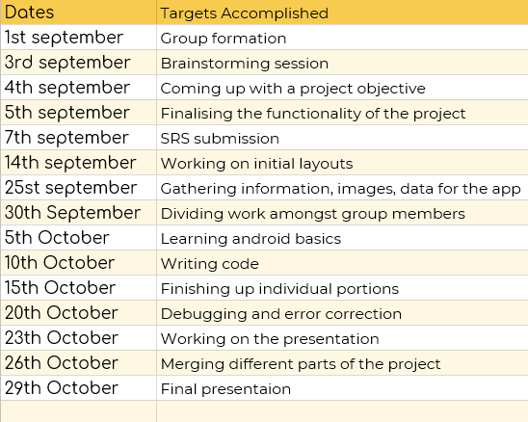

**7.3 Data Collection**

Sources for the following are-

**Contact for help**

* www.justdial.com

**Survival Manual**

* [www.medicalnewstoday.com](http://www.medicalnewstoday.com)
* www.moodpath.de/en/

**Know Thyself**

* [www.16personalities.com](http://www.16personalities.com)
* developer.android.com

**Monitor Yourself**

Clinically validated tests -

* PTSD Test- US Department of Veterans Affairs
* Depression Test- Duke University
* ADHD Test- Duke University
* Borderline Personality- University of Iowa
* Anxiety- Columbia University

**Mood Lifter**

* Stories -www.pickyourgoals.com
* Memes - 9gag.com
* Music - Personal playlist
* Quotes - www.brainyquote.com

**8.Project Design**

**8.1 Code Snippets**

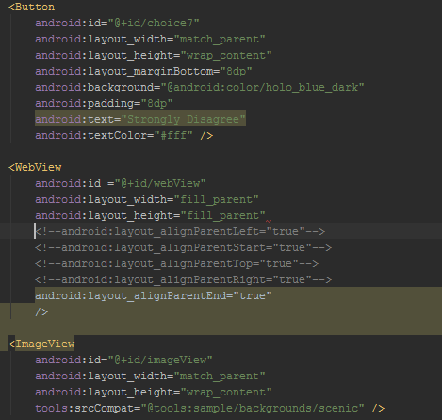

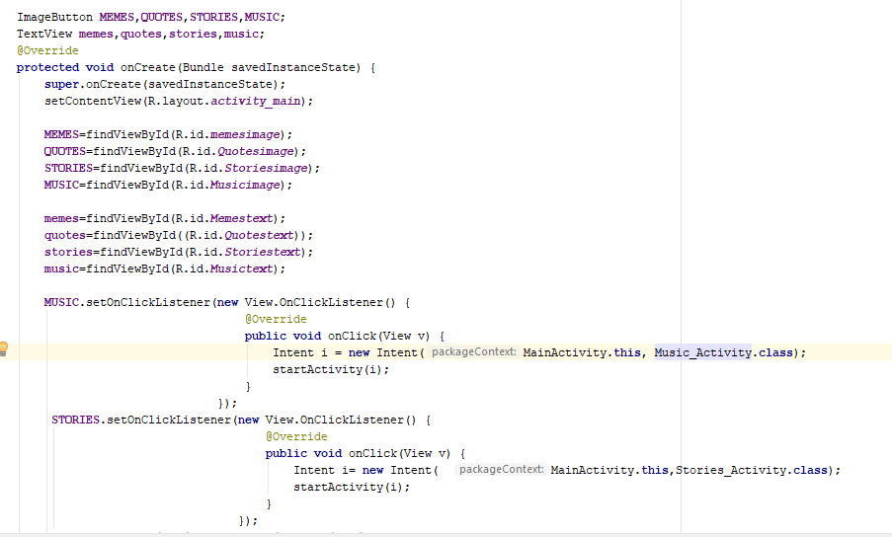

**8.2 Layouts**

Homepage & Signup Page

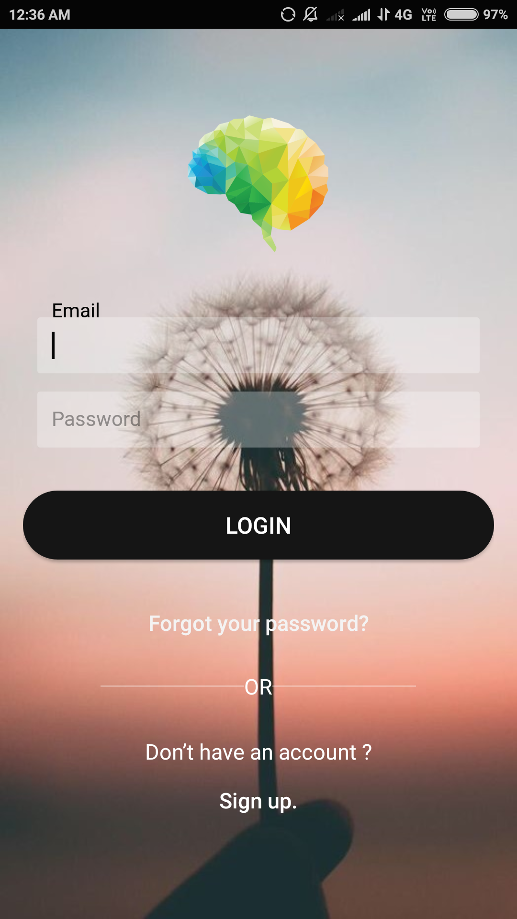 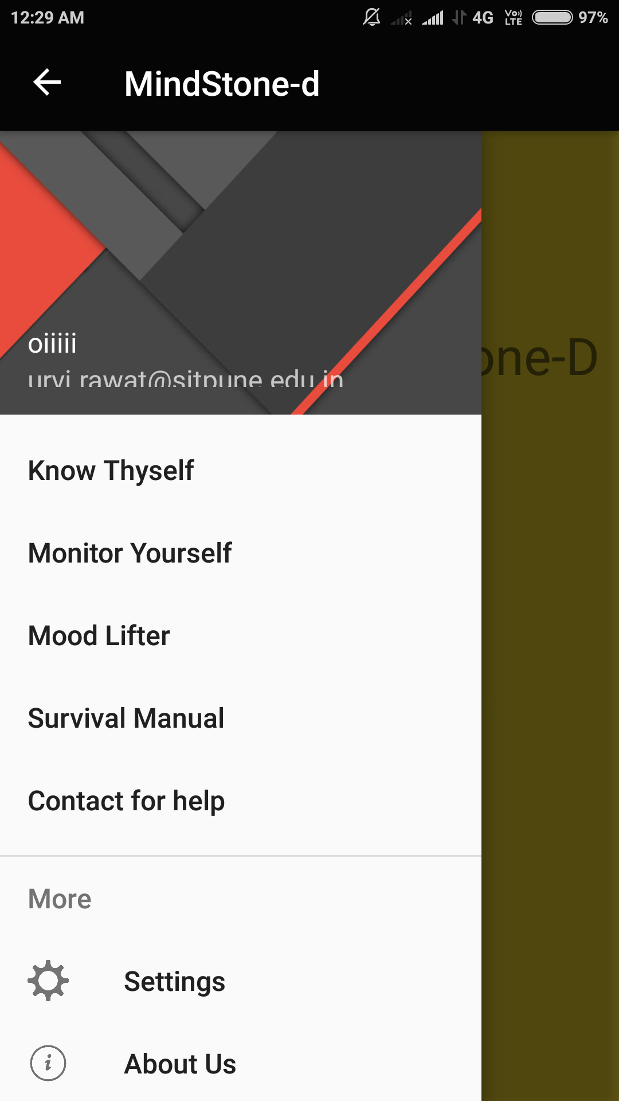

Mood Lifter:

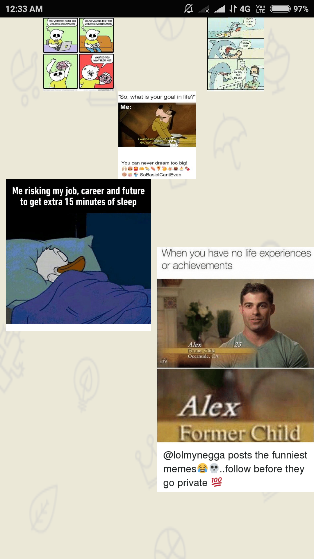 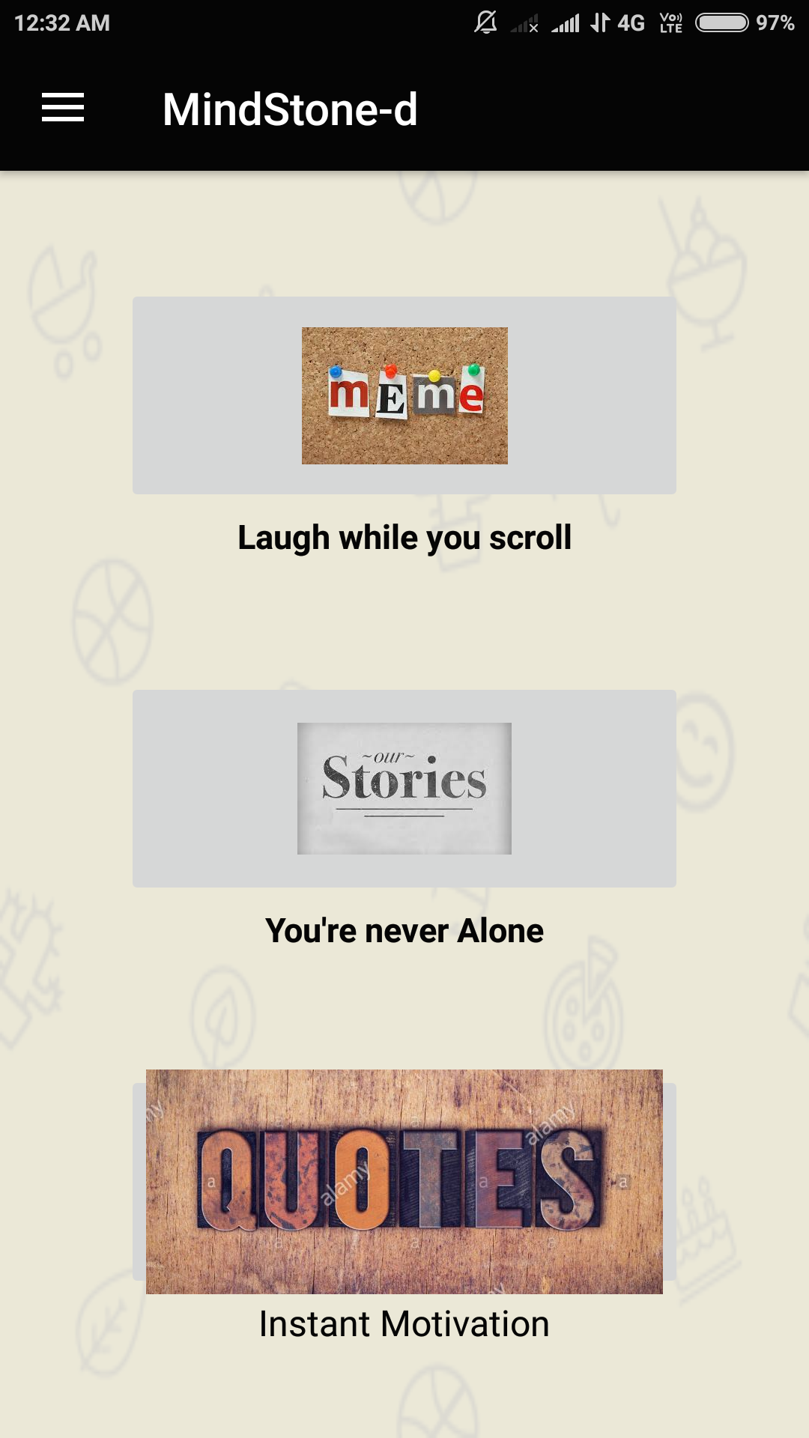 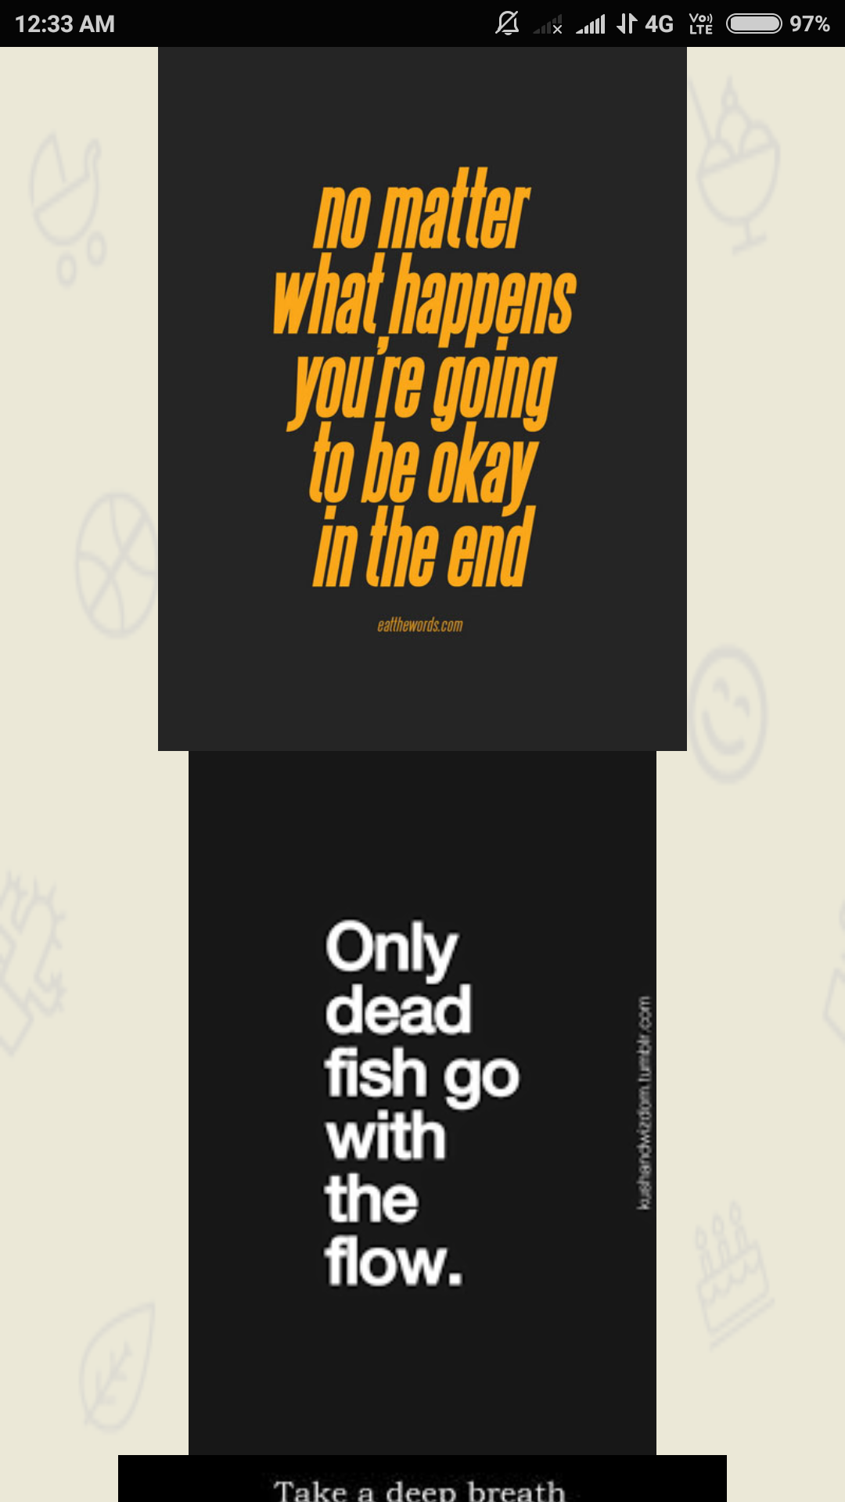

Monitor Yourself:

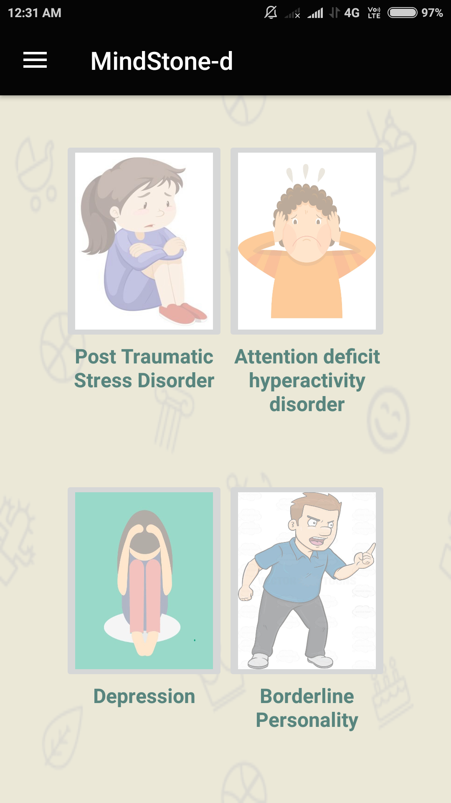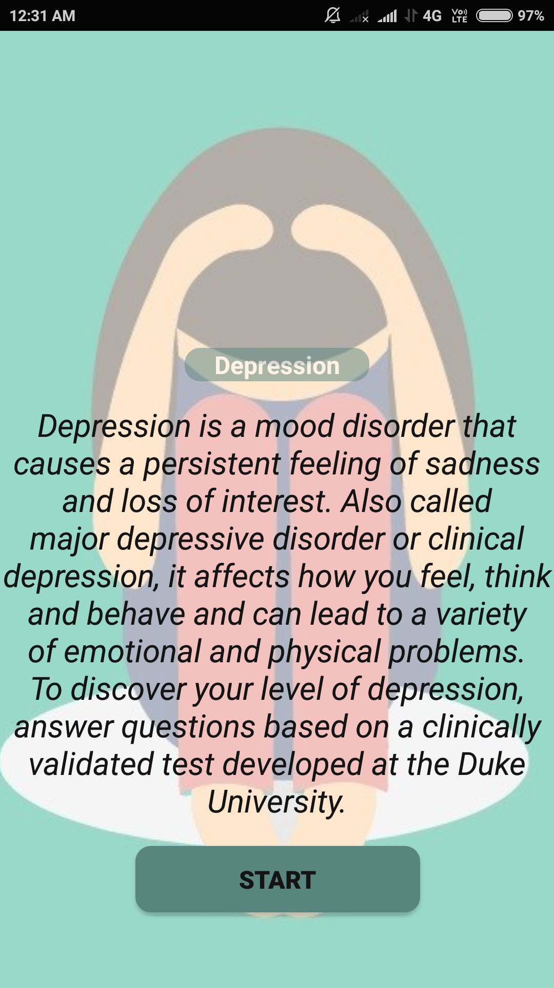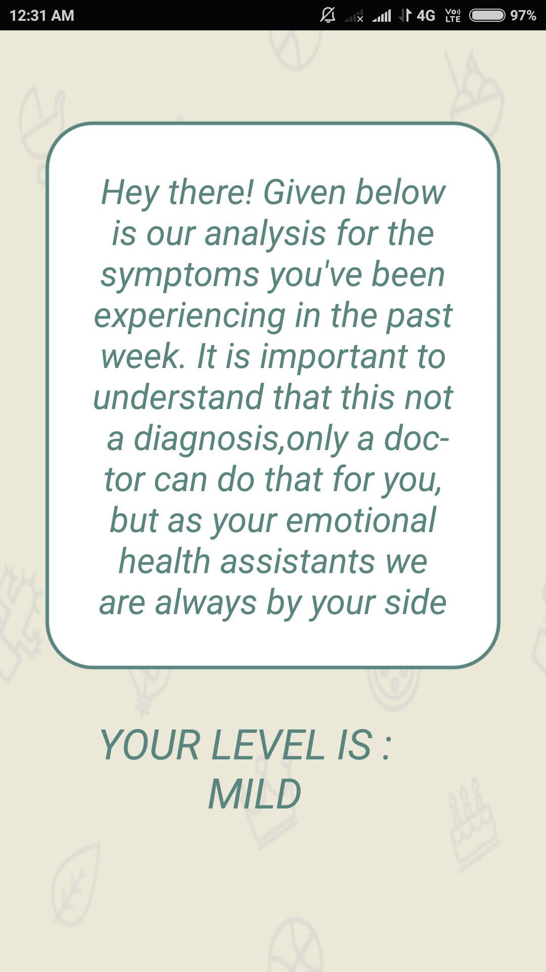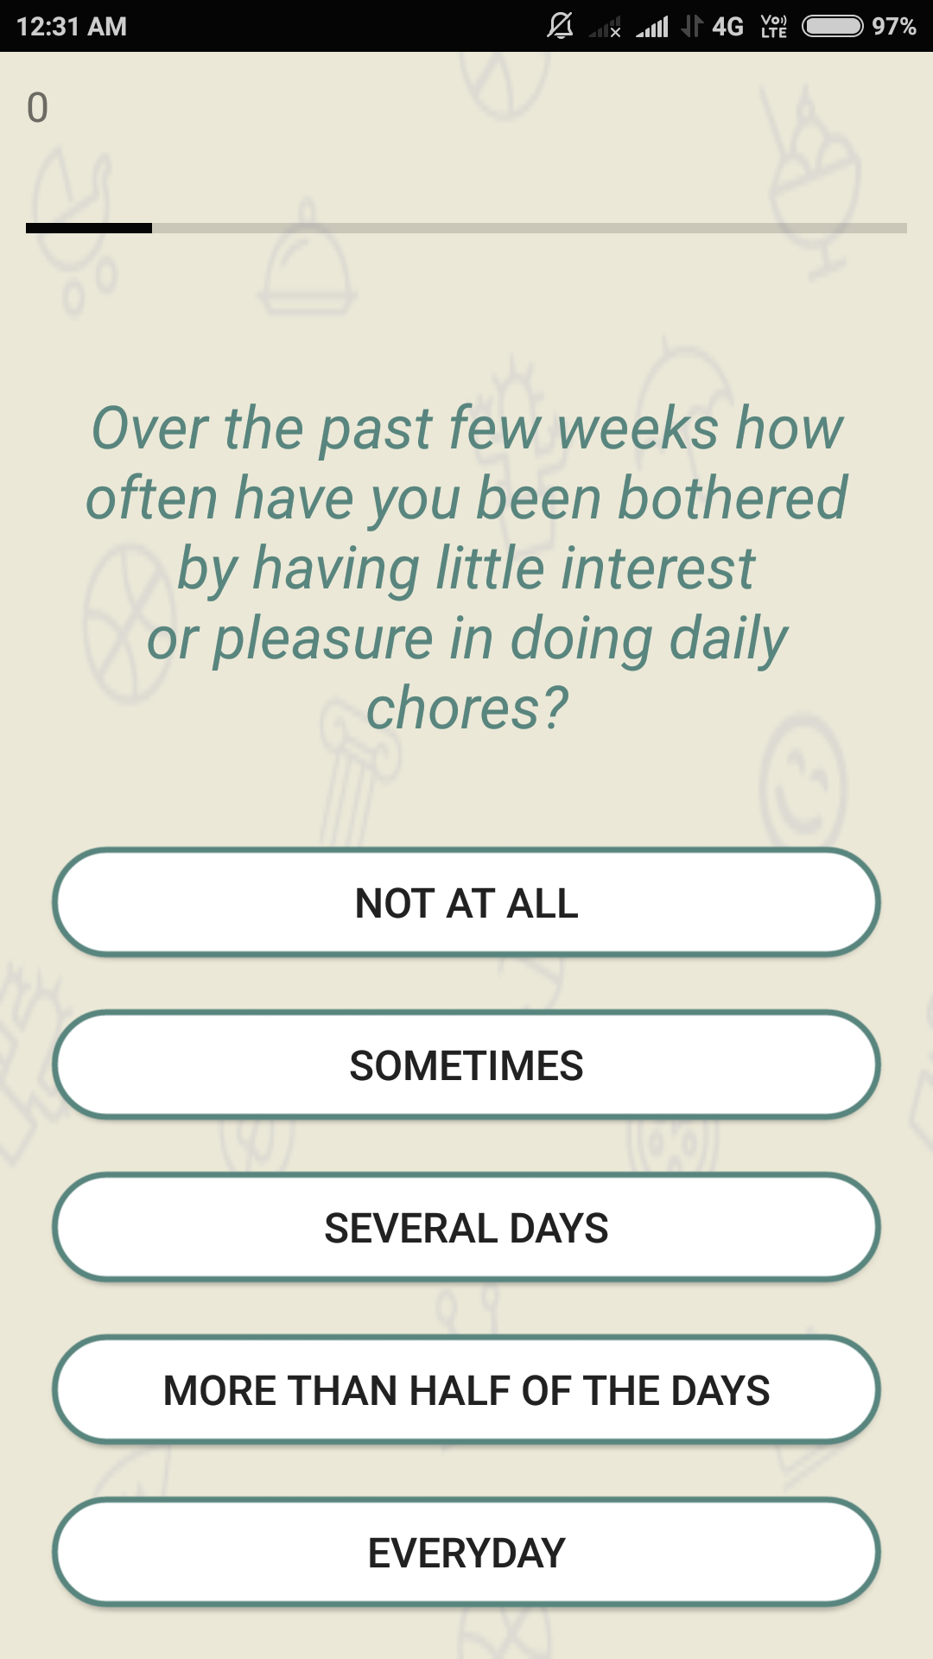

Survival Manual:

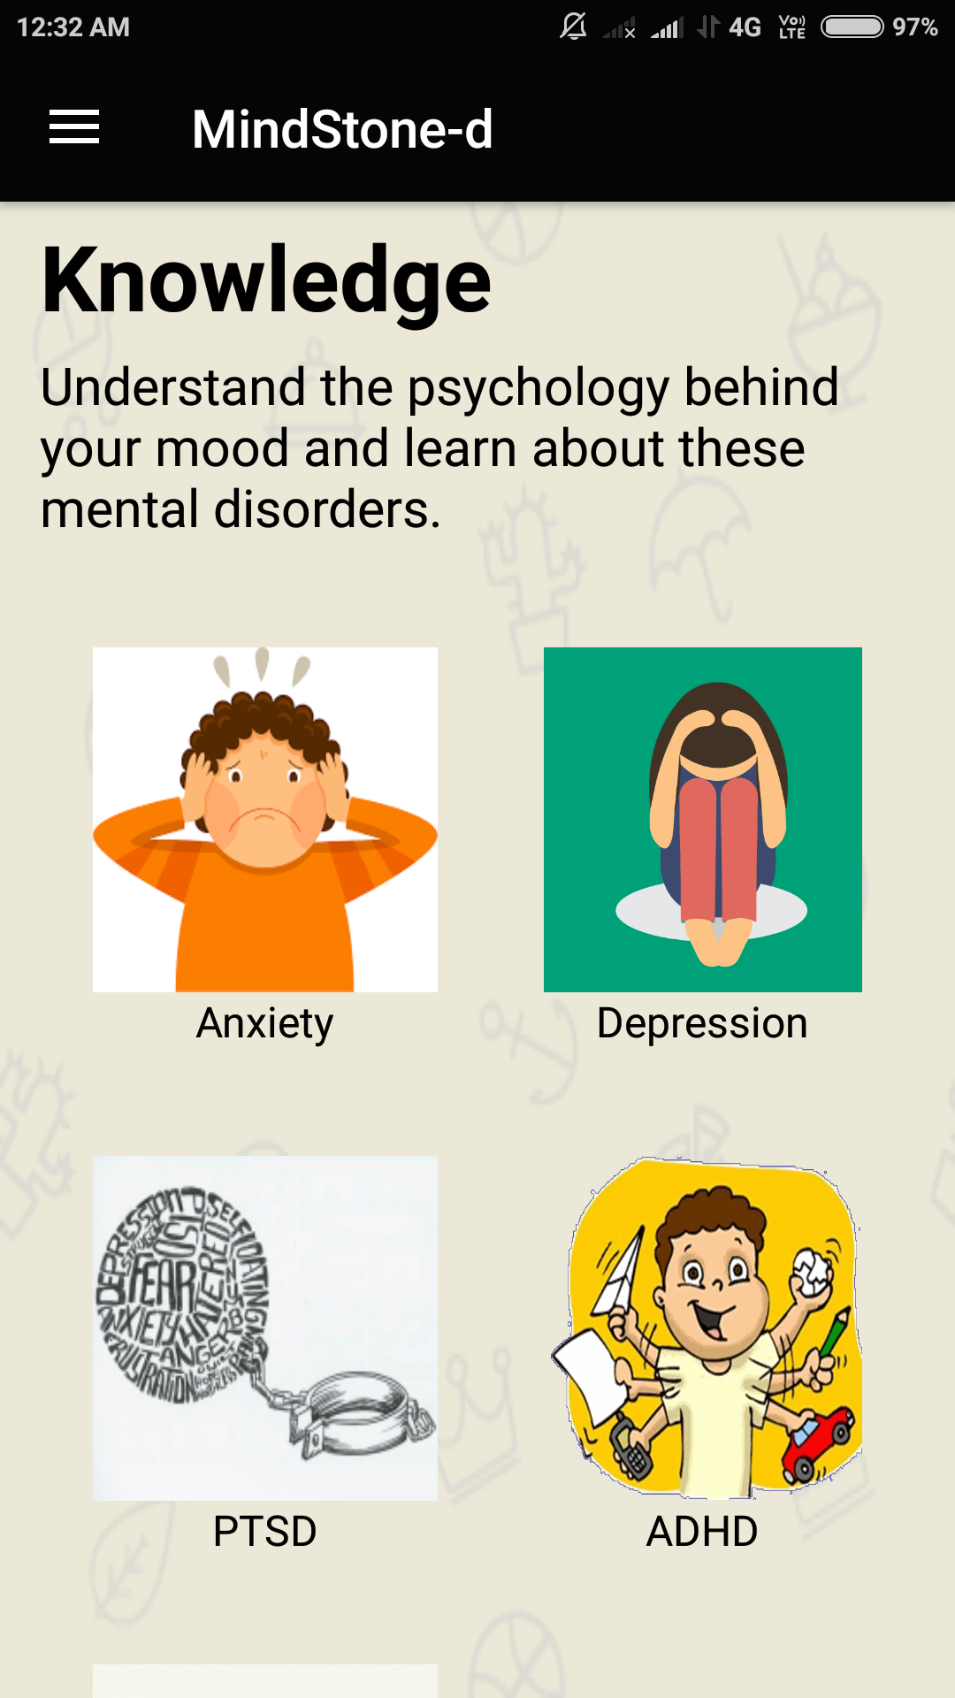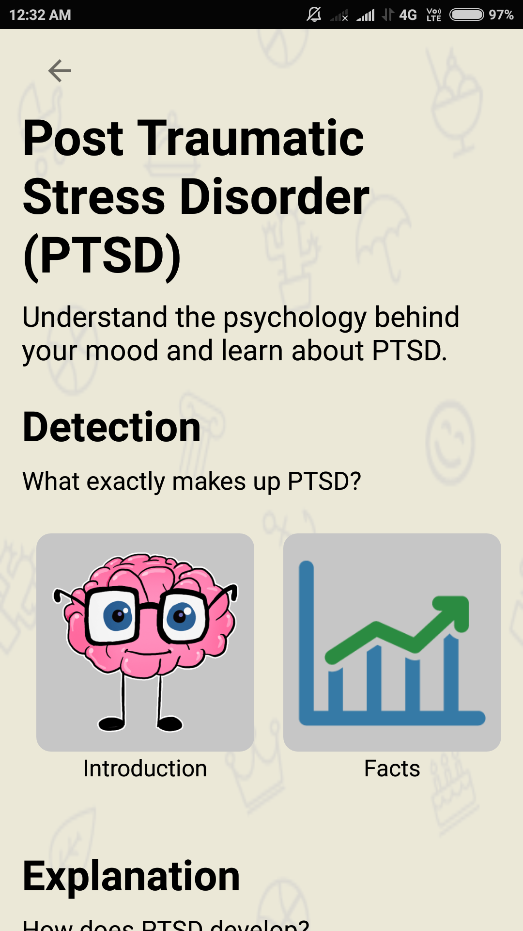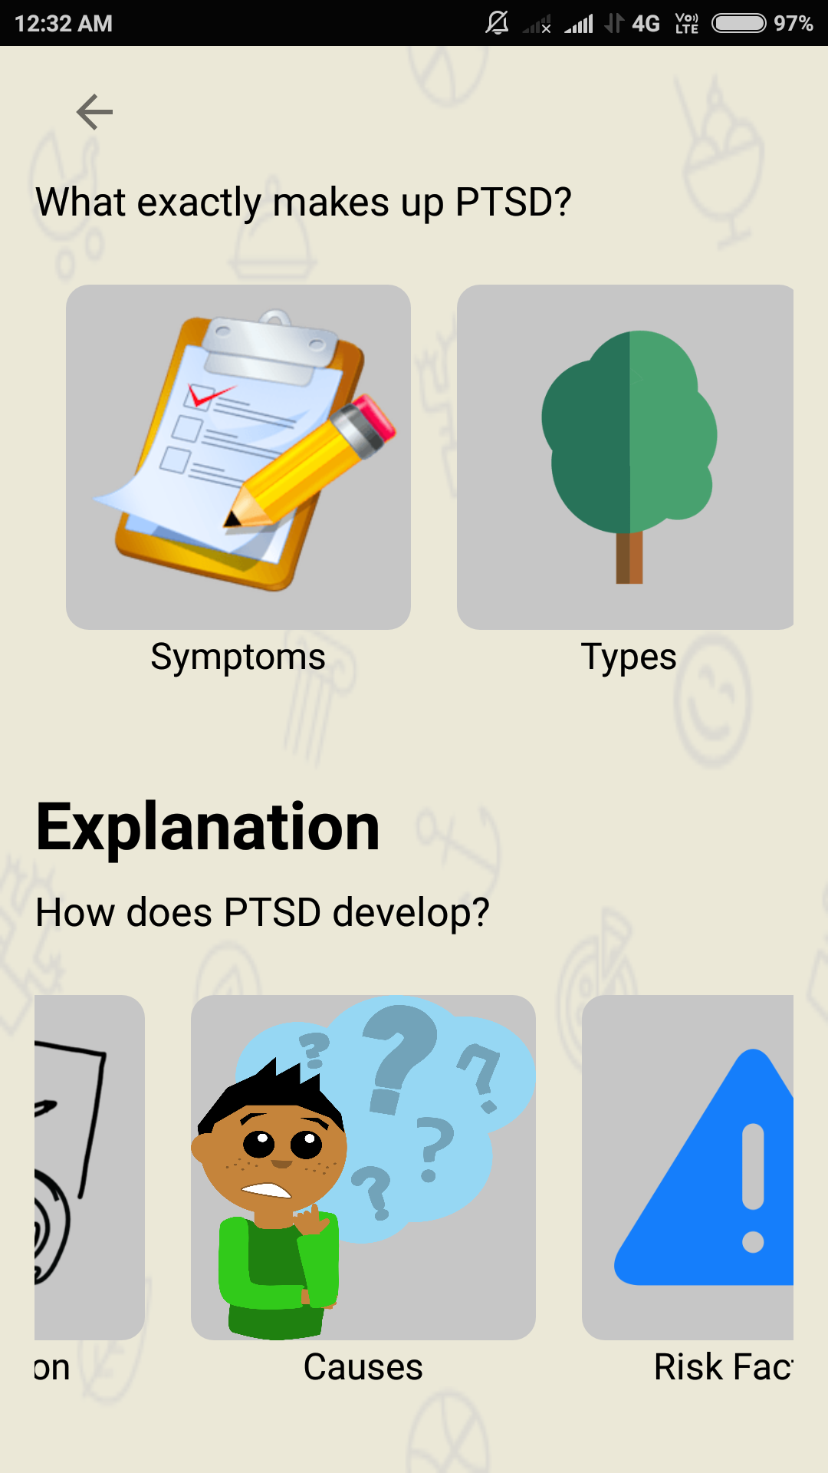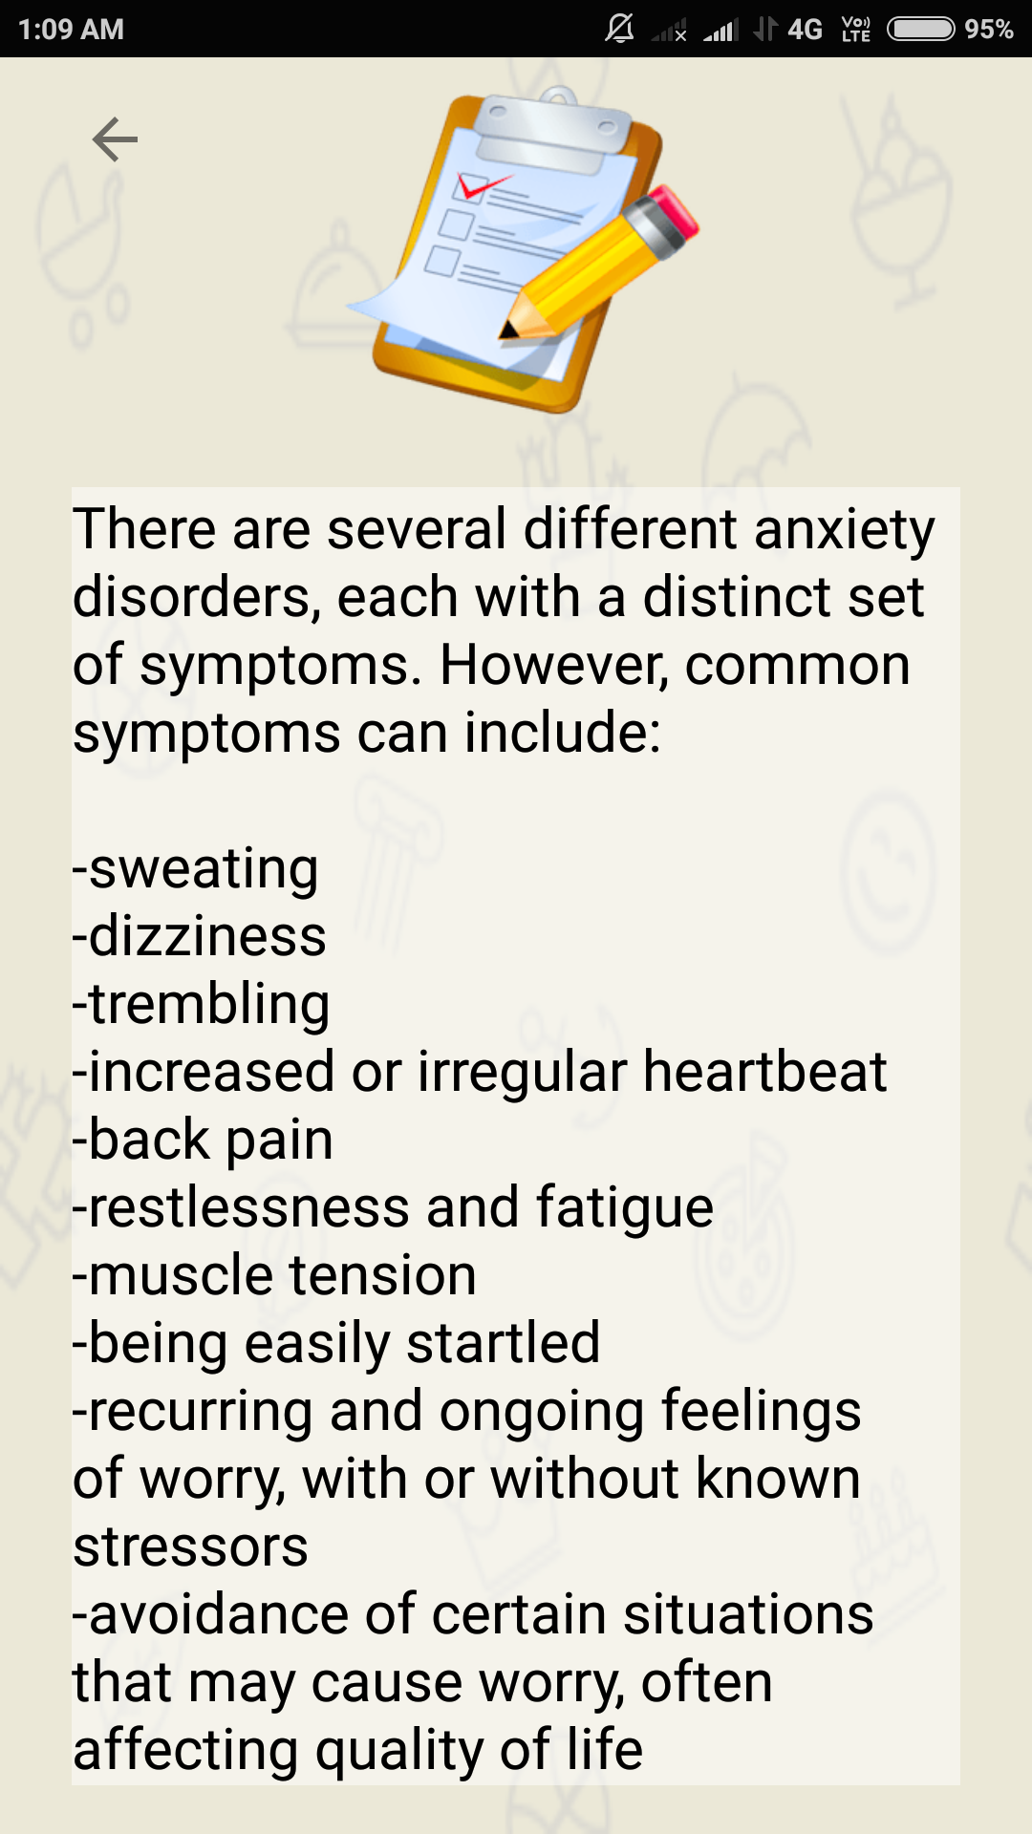

Know ThySelf Contact For Help 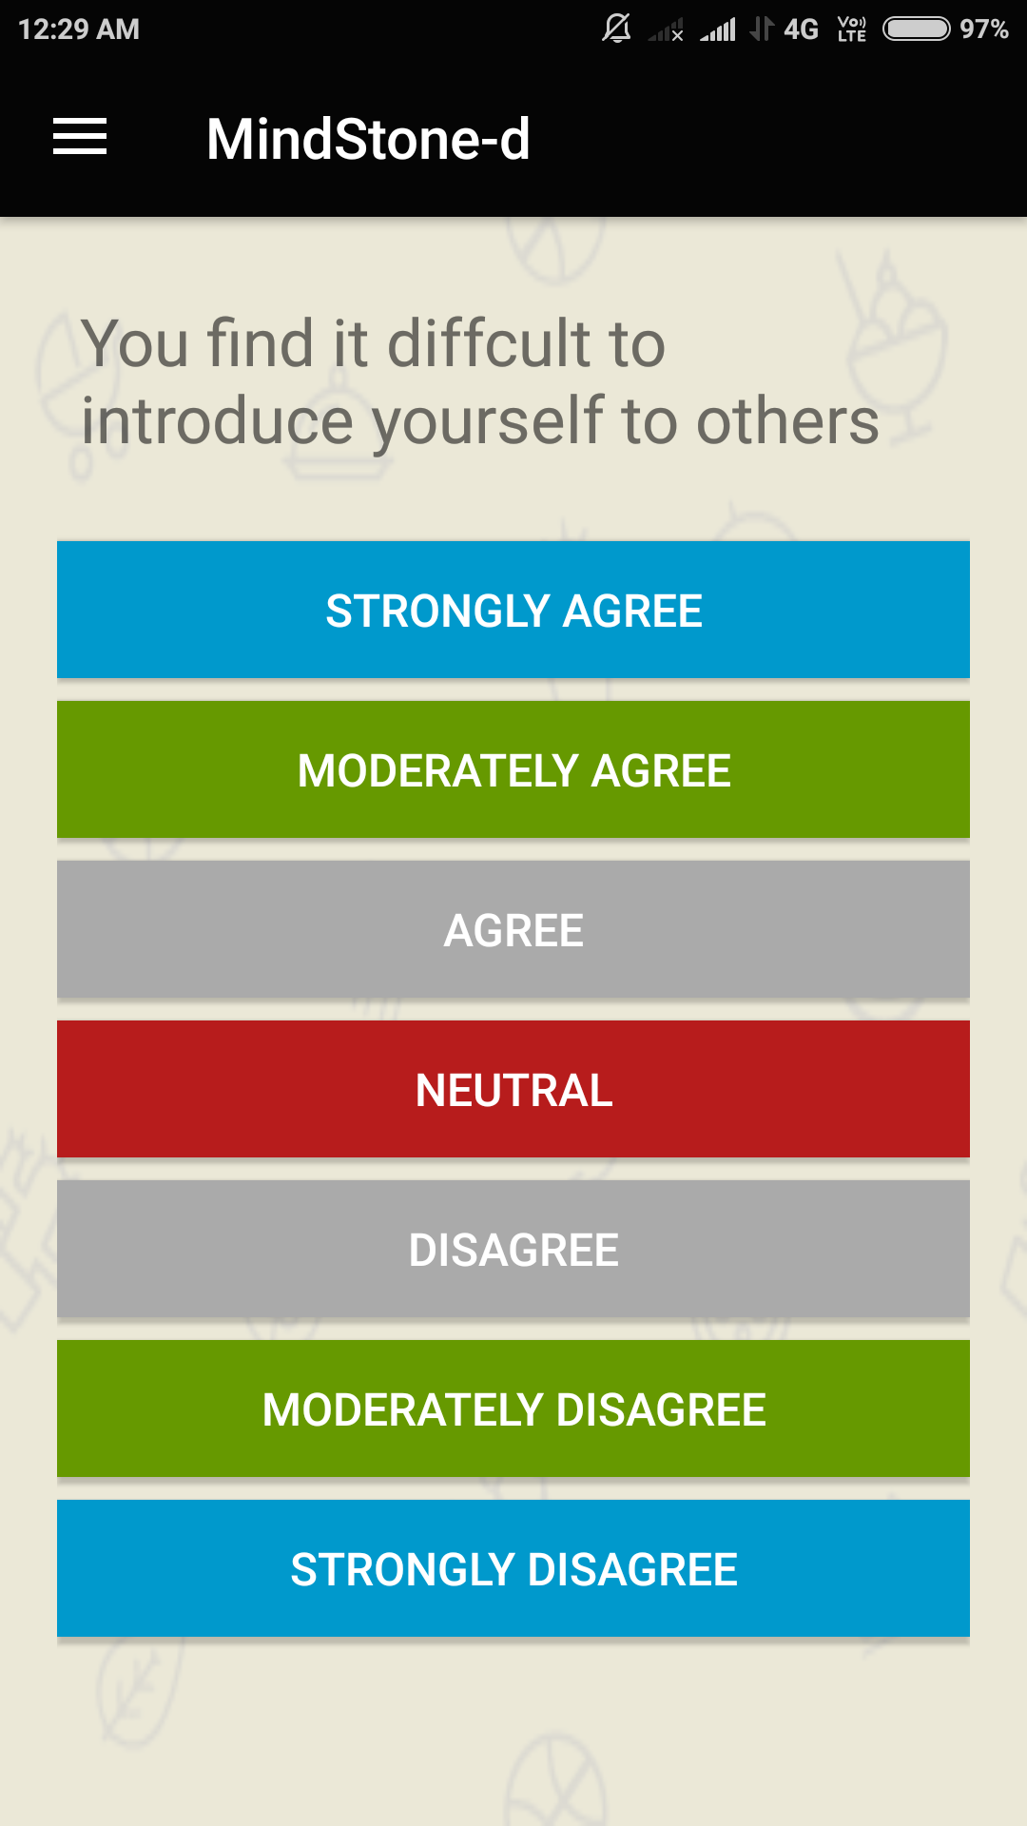 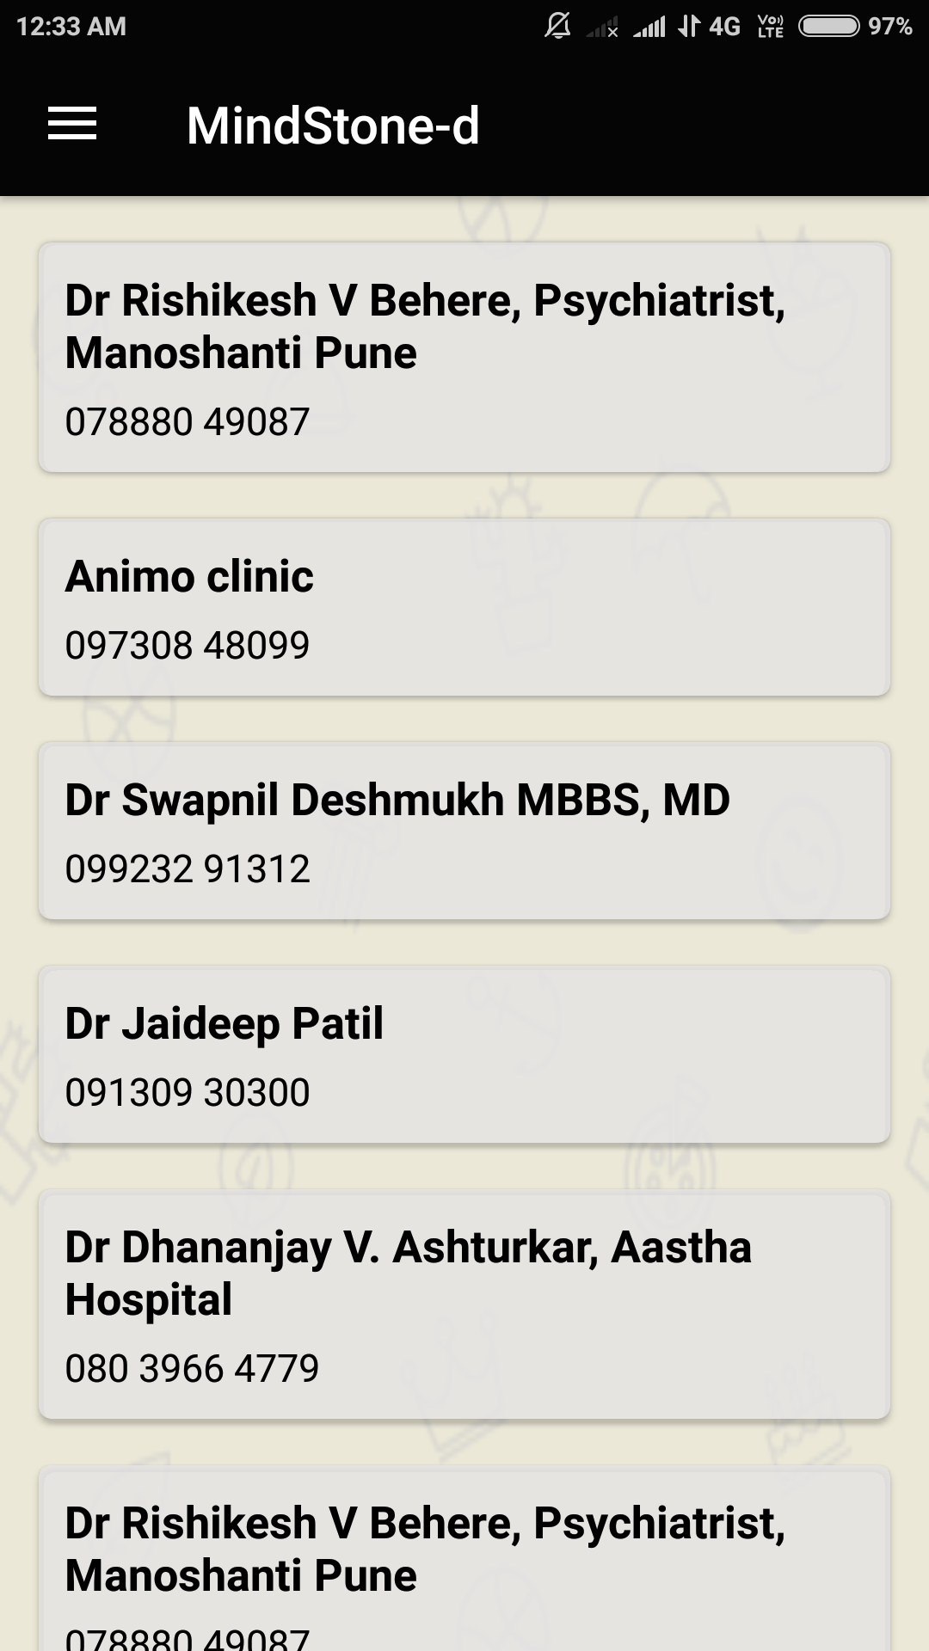

Settings

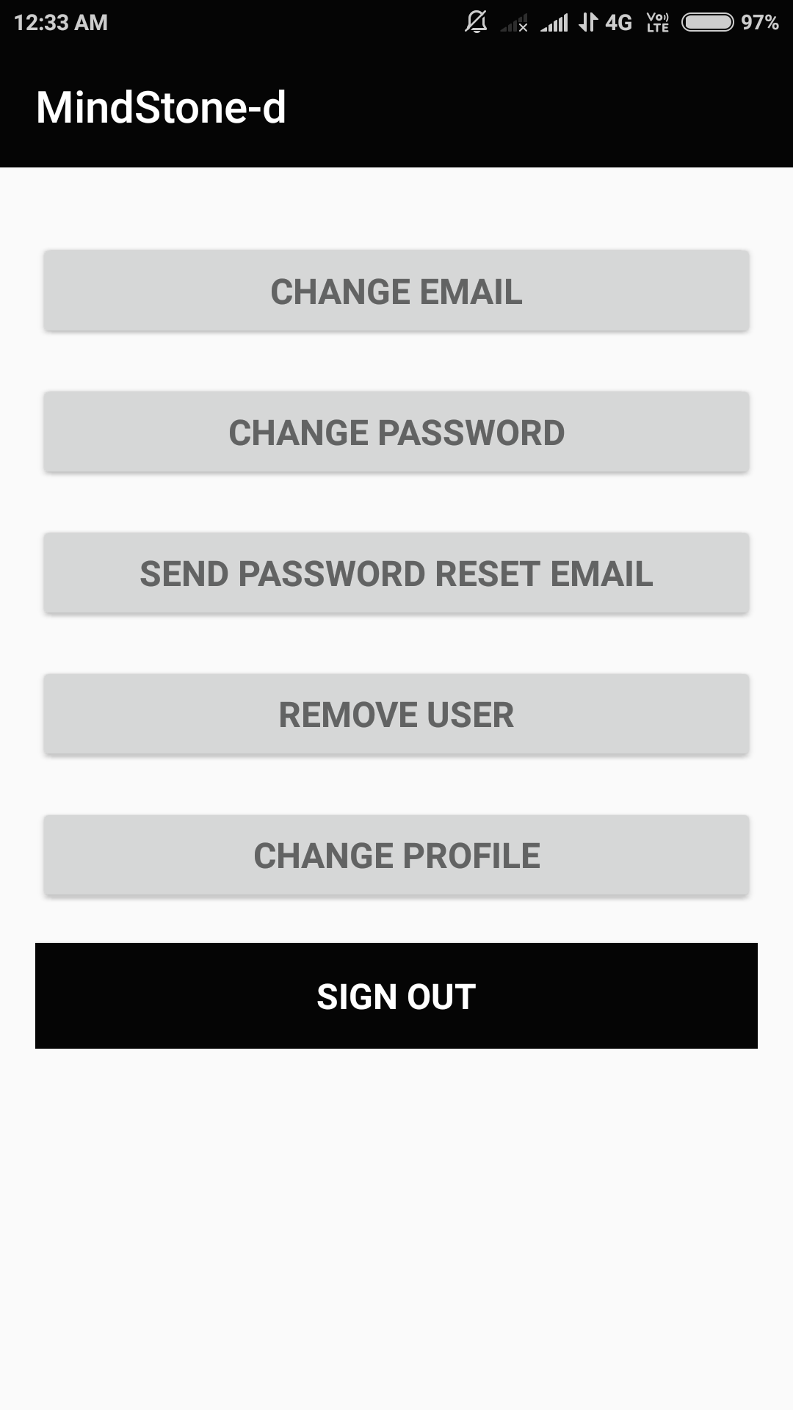

**9. Implementation**

**9.1 Modules**

##### **Know Thyself**

This is a short question answer session, made to gauge the personality of the user. By responding to each question, the interests and mindset of the user becomes clearer to us. We can gain insights about their mood at a particular moment. This information can turn out to be very useful during therapy.

##### **2. Monitor Yourself**

The user is provided with an interactive questionnaire to check for early signs of Depression, Anxiety, Bipolar disorder, Stress etc. It is a self-assessment test to see if the user may be someone who could benefit from the treatment and support of a mental health professional. The mental disorder(if any) and it’s severity will be informed to the user.

He/she will be prompted to fill this once in every 15 days.

##### **3. Mood lifter**

This segment is intended to uplift the mood of those who feel sad and dejected. Complete with soothing music and meditation techniques, mood lifter calms your anxiety and fills you with a sense of joy. It provides relief to those who are too caught up in their thoughts.

##### **4. Survival manual**

The road to recovery starts from becoming self-aware. In order to battle mental illness one must know the root cause. This is where this portion of the app comes into play. By providing a collection of articles, it equips the user with the desired knowledge, helping them learn more about what's happening to them, both emotionally and psychologically, and how it affects their body and daily routine. It keeps them up to date with the latest discoveries in this field and best techniques of therapy.

##### **5. Contact for help**

This section will provide the contact details of various psychiatrist from various parts of the city. They will be available on call during a particular time interval. It will also specify other helplines (Institutions and NGOs promoting mental health). They have trained counsellors professionally helping people out in times of distress or suicidal thoughts.

**9.2 System Model**

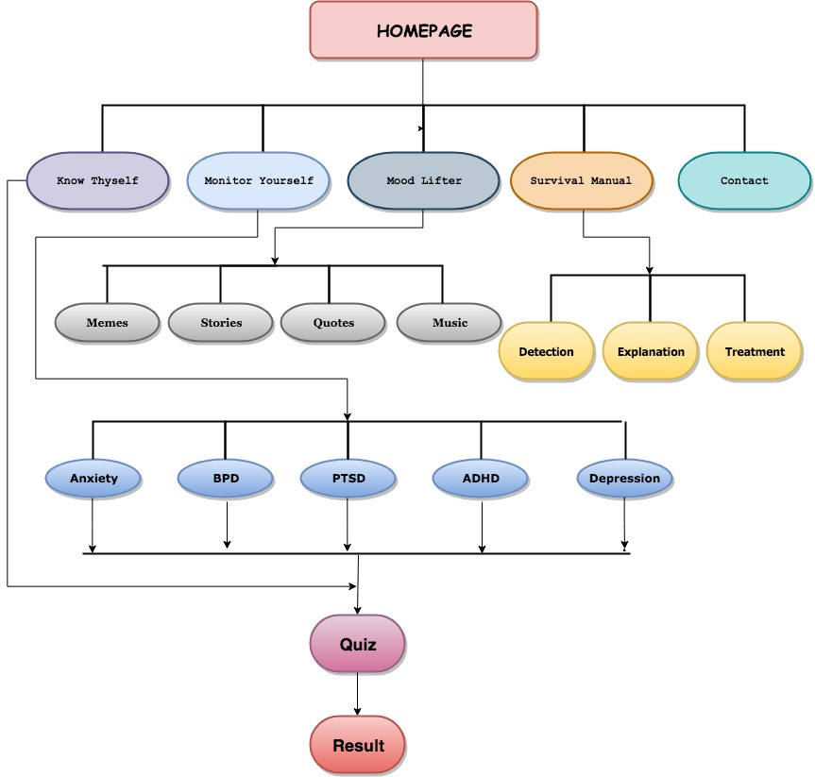

**10. Testing**

**10.1 Debugging**

Errors experienced-

1) Mood Lifter - Issues in Intent

2) Monitor Yourself - Type Conversion Error, Scroll View Error

3) Contact For Help- Issue in Page Adapter for recyclerview

4) Survival Manual - Memory exhausted during runtime, Button Shapes

5) Know Thy Self- Index out of bounds in Activity Thread

**10.2 User Feedback and Analysis**

After conducting surveys in our college campus and circulating feedback forms among potential users in our hometowns we received 152 responses, following was the feedback we received and the analysis of the same.

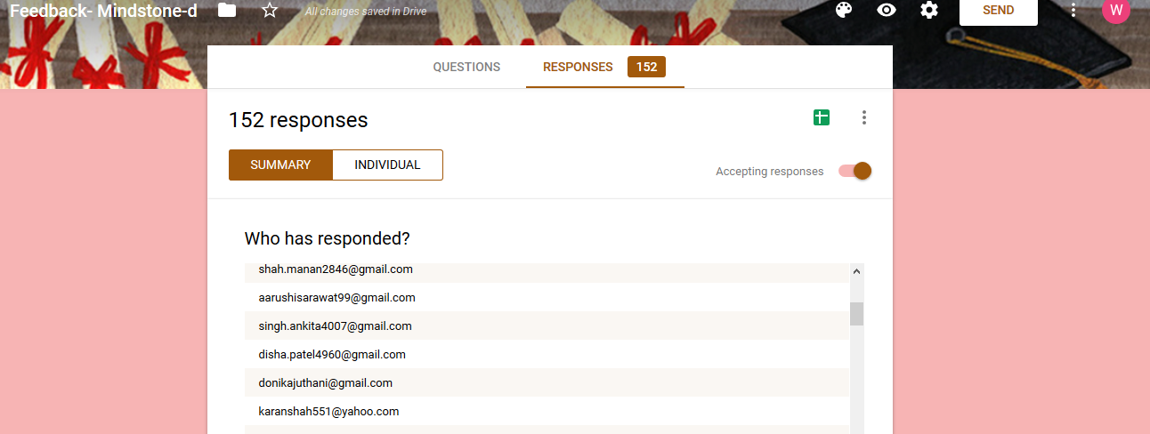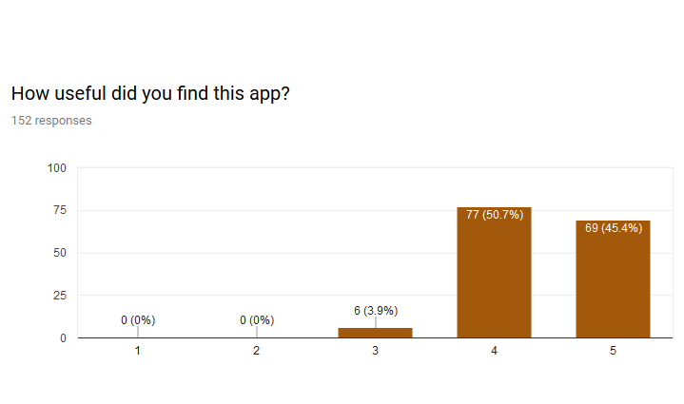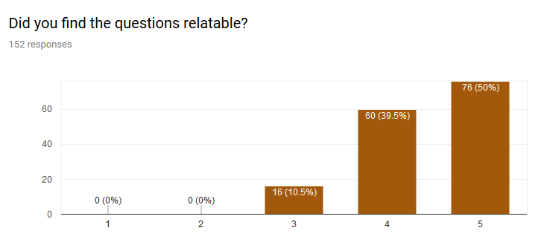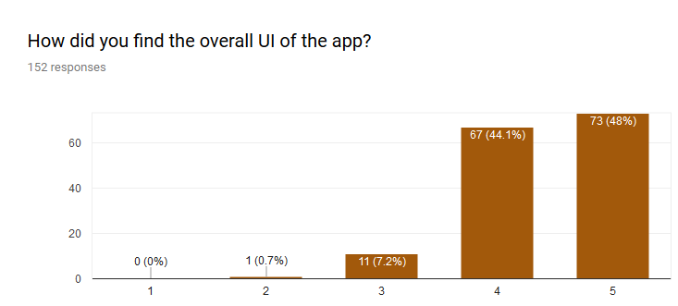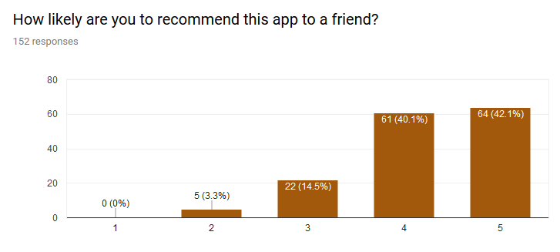

**11. Conclusion and Future Enhancements**

With our app, it is our aim to help society in the following ways:

* Allow doctor to gain details faster.
* Helps stay up to date with your mental health
* Helps you connect with doctors in your vicinity
* Checks warning signs for early stage mental disorders
* Stay informed about recent discoveries in the medical world

**Future Enhancements:**

* Collaboration with Entrepreneurship Promotion and Innovation Cell, to be part of their Social Entrepreneurship Awareness Camps
* In talks with two NGOs to be part of their mental health awareness campaigns.

1. Teach For Tomorrow (A student initiative)

2. Parvaah (Jaipur Based NGO)